**[Modifying centroid locations in an image – an application of linear indexing](http://blogs.mathworks.com/steve/2011/12/28/modifying-centroid-locations-in-an-image-an-application-of-linear-indexing/" \o "Permanent Link to Modifying centroid locations in an image – an application of linear indexing)**

Blog reader Mike posed the following question [recently](http://blogs.mathworks.com/steve/2006/06/10/determining-point-position-in-mri-phantom/#comment-24640):

If you have a bunch of point locations (for example, object centroids), how you make a binary image containing just those points?

For example, consider this image:

bw = imread('text.png');

imshow(bw, 'InitialMagnification', 200)

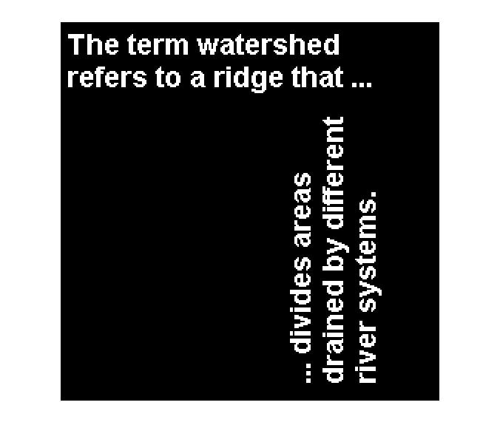

How can we make an image like this, where the dots are located at the centroids of the objects?

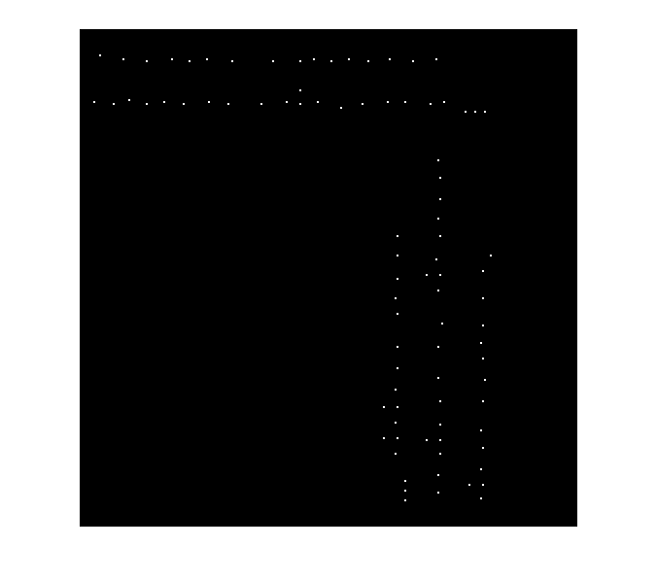

Solving this problem is a nice application of linear indexing, something I wrote about in this blog a [long time ago](http://blogs.mathworks.com/steve/2008/02/08/linear-indexing/). Let's see how it can work for us here.

First, let's find the centroids using regionprops:

s = regionprops(bw, 'Centroid');

s is a struct array. Since we just asked for one measurement, the centroid, each element of s is a struct containing just one field, 'Centroid'.

s(1)

*ans =*

*Centroid: [11 13.5000]*

s(2)

*ans =*

*Centroid: [7.6829 38.1707]*

The length of s is the number of objects in the image.

num_objects = length(s)

*num_objects =*

*88*

Next, we gather all the individual centroid locations into x and y vectors. To accomplish this I use the [comma-separated list syntax for struct arrays](http://www.mathworks.com/help/releases/R2011b/techdoc/matlab_prog/br04bw6-38.html#bs6e2p_).

centroids = cat(1, s.Centroid);

x = centroids(:,1);

y = centroids(:,2);

If the comma-separated list syntax makes your brain hurt, you can use a loop instead:

centroids = zeros(length(s), 2);

for k = 1:length(s)

centroids(k,:) = s(k).Centroid;

end

Now let's round the centroid locations to get row and column subscripts.

r = round(y);

c = round(x);

Here's where linear indexing comes into play. In order to assign to a bunch of scattered locations like this, you want to use a single subscript. That's what we call linear indexing. You can use the function sub2ind to convert a set of subscripts to linear indices.

ind = sub2ind(size(bw), r, c);

And finally we can use the linear indices to assign a value to a bunch of image pixel locations all at once.

bw2 = false(size(bw));

bw2(ind) = true;

imshow(bw2, 'InitialMagnification', 200)



See my [08-Feb-2008 blog post](http://blogs.mathworks.com/steve/2008/02/08/linear-indexing/) for more about linear indexing.